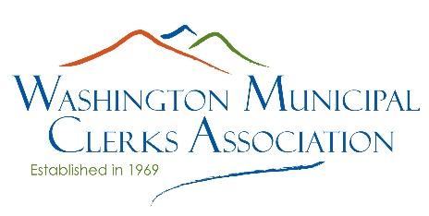
SCHOLARSHIP APPLICATION
Please complete all sections of the application.

Name: Email:

Employer: Job Title:

Employer Address:

Start date in current job: How long in clerk profession:

WMCA Membership Class: Active Affiliate Associate None; Joining now
(check one)
If you are an Associate/Affiliate member, are you employed by a legislative body? Yes No N/A
Are you currently a member of IIMC? Yes No
Which of the following events and item are you applying for a scholarship? *Note: please select either registration or lodging.
WMCA Annual Conference Registration or Lodging
First-time WMCA Annual Conference attendee (scholarship includes both registration and lodging)
Spring Academy only Registration or Lodging
IIMC Annual Conference Registration (up to $500) Registration or Lodging
IIMC Advanced Academy (up to $500) Registration or Lodging
Combined Fall Mini-Conference Registration or Lodging
Fall Academy Registration or Lodging
Fall Athenian Dialogue Registration or Lodging
Northwest Clerks Institute (NCI):
Professional Development 1 Registration or Lodging or Both
(both registration & housing on campus can be applied for)
Professional Development 2 Registration or Lodging
Professional Development 3 Registration or Lodging
Professional Development 4 Registration or Lodging

What WMCA Committees are you currently serving on?

Do you have your Certified Municipal Clerk (CMC) designation? Yes No
If no, are you pursuing your CMC? Yes No
Have you attended this event before? Yes No
Have you ever received a scholarship from WMCA? Yes No
Have you included a letter of support from your supervisor, as required? Yes No

I hereby attest the information submitted in this application is true and accurate to the best of my knowledge.

I have included a letter of support from my supervisor, as required.

I understand and agree that I will need to complete the requirements of the scholarship award including full attendance at the event, completion of a KTAP (if applicable), and future participation on the fundraising committee.

Signature: Date submitted:

Please submit the completed application materials by email to:
Kim Agfalvi
City of Orting
kagfalvi@cityoforting.org
For additional information or questions, please call (360) 893-9008

Late applications will not be considered.
Please see the WMCA scholarship webpage for specific deadline information.

